Your Designated Child Protection Team are:
Mrs Georgie Robinson  Assistant Principal  Senior Designated Safeguarding Lead  Online Safety Lead | 
Mrs Leanna Govan  Family Support Worker  Deputy Designated Safeguarding Lead  EHA lead | 
Miss Katherine Hipwell  Phase Leader  Deputy Designated Safeguarding Lead  Prevent Lead | 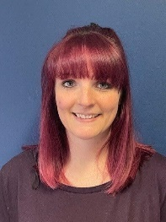
Mrs Katherine Armstrong  Teacher  Deputy Designated Safeguarding Lead  FGM lead | 

