MATHEMATICS CALCULATION POLICY

This section should be completed following ratification of the Policy.

Audience | Trust Leaders, All teachers, all school staff, parents via website
Ratified | July 2022
Other Related Policies | Alignment Policy
Policy Owner | Executive Team
Review Frequency | Every two years

Ownership
Preston Hedges Trust is responsible for the production and maintenance of this document. It is issued by the Clerk, catherine.gautrey@prestonhedges.org to whom any change requests or queries should be directed.


Mathematics Calculation Policy
This calculation policy has been written in response to the National Curriculum for the teaching and learning of Mathematics, and is also designed to give pupils a consistent and smooth progression of learning in calculations across a child’s school life.
Non-negotiable written method table

Year Group | Addition | Subtraction | Multiplication | Division
R | Concrete objects* and pictorial representations | Concrete objects and pictorial representations | Concrete objects and pictorial representations | Concrete objects and sharing
1 | Pictorial representations and Number lines | Pictorial Representations | Pictorial Representations and Arrays | Pictorial Grouping
2 | Number Lines and (Expanded) Column Method | Number Lines | Repeated Addition and Grid Method | Number Line
3 | Column Addition (Carrying) | Decomposition | Short Multiplication | Number Line (jumping in multiples x10, x5, x2) and Bus stop
4 | Column Addition | Decomposition | Short Multiplication | Bus Stop
5 | Column Addition | Decomposition | Short Multiplication | Bus Stop and Long Division
6 | Column Addition | Decomposition | Short Multiplication | Bus Stop Long Division
*It is a Trust expectation that concrete objects (manipulatives) are used beyond Year R and throughout school as required providing support to our children
EYFS
EYFS

Addition

Before adding, children in Early Years develop their understanding of number sense to start the foundation of their mathematical understanding. Initially, when children begin to add numbers they use concrete objects to add two groups of objects together to find a total amount.
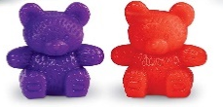
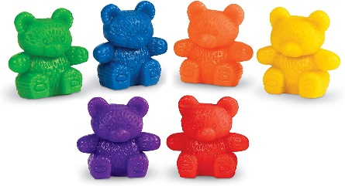

- + 2 = 8
Children use 1:1 correspondence to find the total number of items in two groups by counting them all. Children use concrete objects to solve real world mathematical problems involving adding. Once the children have developed their understanding using objects, pictorial representations are used to add two groups of objects.

3 + 2 = 5
Children then progress to adding two single-digit numbers by counting on to find the answer using quantities, objects and pictures.

EYFS

Subtraction

For subtraction, children use concrete objects by taking away an amount from a larger about of objects.
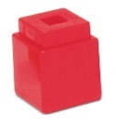

7 - 3 = 4

Children also use pictorial representations to support subtraction. They will then progress to subtract two single digit numbers and count back to find the answer, using quantities, objects and pictorial representations.

EYFS

Multiplication

For multiplication, children being by exploring patterns in numbers up to 10, including even and odd, and doubling facts using concrete objects. They solve practical problems involving groups 2, 5 and 10 and share objects into equal groups.
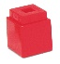

- 4 6 8

EYFS

Division

For division, children solve problems involving halving using concrete objects to share between two people.
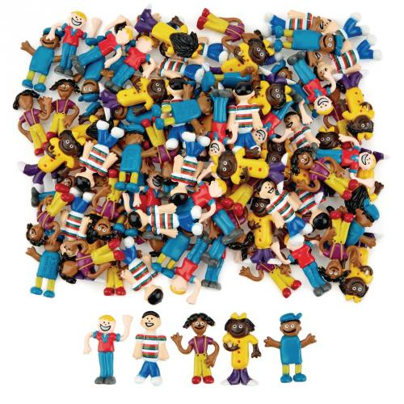
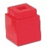

4 shared between 2 = 2.

Key Stage 1

Key Stage 1

Addition

Initially, pictures will be used to solve problems with addition. Children will count totals starting at the number one and later starting on the highest number and counting up.
Example: If I had 6 sweets and then got 3 more, how many would I have in total?
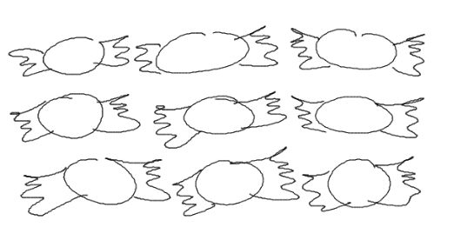
As children become more confident with addition and counting, they will begin at the larger number and count the remaining steps.
7, 8, 9.
Children will begin by using one-to-one correspondence to count totals of numbers.
1, 2, 3, 4, 5, 6, 7, 8, 9 (pointing to each object as they count.

This will progress onto children using a number line to count up from one number to another.
Starting on the larger number and counting the remaining steps (represented as ‘jumps’).

Example: 7 + 4 =

2

3

4

5

6

7

8

9

10

11

12

As children become more confident with number bonds and partitioning of numbers, larger jumps can be made.
Knowledge of number bonds to 20 has been used (adding 4) then knowledge of partitioning (5 is made up of 4 and 1).
Example: 16 + 5 =

+1
+4
12

13

14

15

16

17

18

19

20

21

22

When children begin to add larger numbers they will require a more refined and faster method. Expanded column addition allows children to add larger numbers whilst still retaining place value.
Units are added first (7 + 8 = 15) and recorded in correct columns. The tens are then added (30 + 30 = 60) and again recorded in columns. Finally, the sum of the units and tens are added together.
Example: 37 + 38
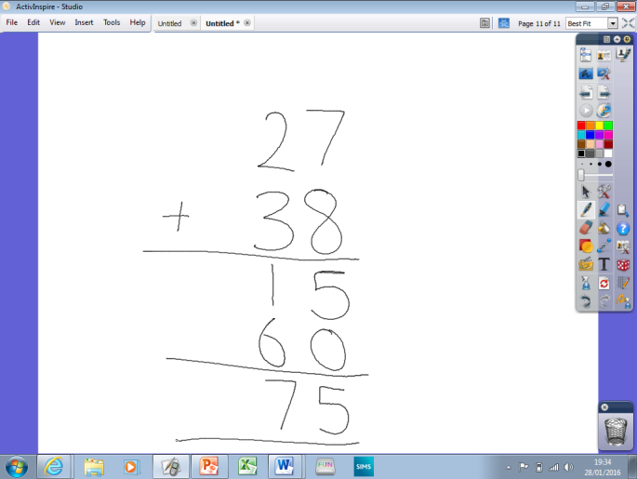

Once children have a secure understanding of the place value system they can begin to look at using the formal written method (column addition) with carrying. This allows additions to be carried out far quicker without the need for partitioned additions.

Example:
Digits are lined up in columns linked to their place value (HTU).

Addition of 9 + 2 equals 11. The first digit (one) is carried forwards underneath the equation to be added onto the addition if the next set of numbers.

Key Stage 1

Subtraction

Similarly to addition, children will begin to tackle subtraction problems using pictorial representations which they can manipulate to find the answer.
Example: 10 – 4
Children cross out the number being subtracted and count the remaining numbers.
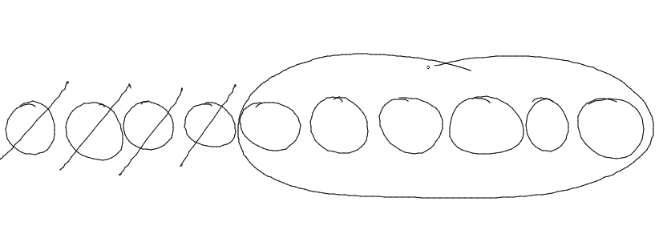

This will develop on to children using a number line to represent. Children will count up from the smaller digit to the larger digit in jumps of one.
Number of ‘jumps’ represents the answer to the problem.
Example: 11 - 7

2

3

4

5

6

7

8

9

10

11

12

Using known number facts (number bonds to 10) children can reduces the time it takes to calculate problems. This will require children to record the value of each jump as they can now represent different numbers.

Example: 15 - 7

1
1
1
1
1
3
5

6

7

8

9

10
11

12

13

14

15

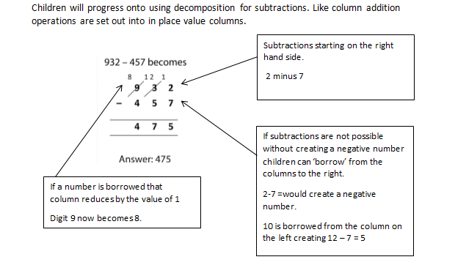

Example:

Key Stage 1
Multiplication

Multiplication begins with children practically grouping and counting sets of objects in sets of ones, twos or fives. This will progress onto pictorial representations of problems.
Example: One hand has 5 fingers, how many fingers are on 3 hands altogether?
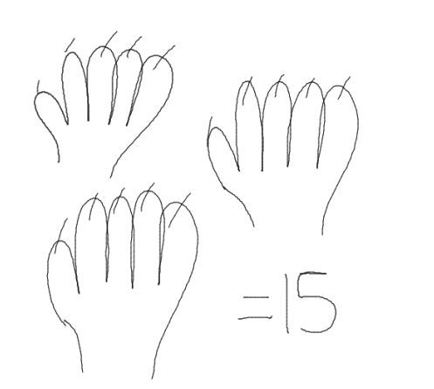
As the children count the number, they can cross off what they have counted.

Eventually, children will record numbers alongside their representations.
Example: One cake has 4 candles on it, how many candles would 4 cakes have altogether?
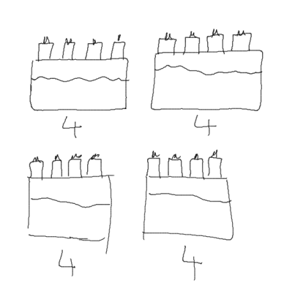

With numbers under each representation children can begin to see the idea of repeated addition.
4 + 4 + 4 + 4

The next stage is for children to record problems as arrays.
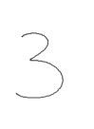
Example: You get 4 strawberries in 1 packet, how many are in 3 packets in total?
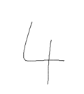


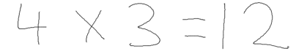
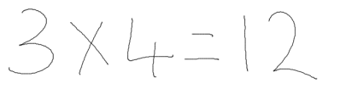

This also allows children to see the commutative nature of multiplications.
3 x 4 is the same as 4 x 3
Operations can be recorded underneath the array representations.

Moving on from this, children will record equations on a number line jumping in multiples.
Example: 6 x 5

0

25
20
10
15
5

30
Having learnt the commutative nature of multiplication, children can choose which multiples to jump in. Here 5 is an easier times table to count in rather than 6.

Grid method introduces a process that allows larger numbers to be multiplied more efficiently.
After the multiplications have been carried out, column addition can be used to find the answer.
Example:
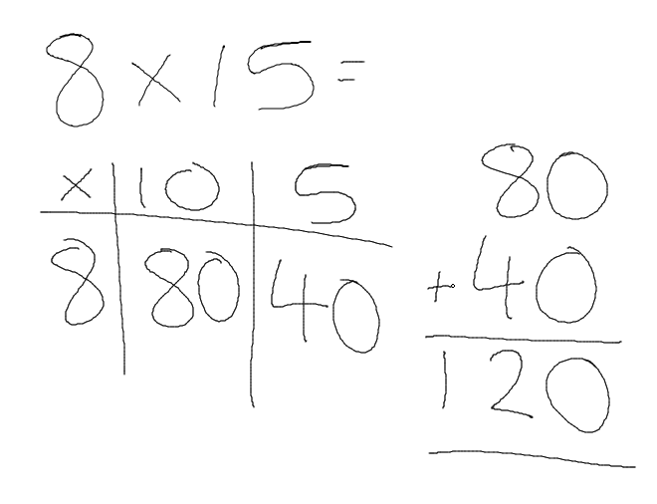

It is important children understand the value of the digit 1 as 10 in the number 15.

Key Stage 1

Division

Division will begin with children physically dividing (sharing) objects into equal groups.
Example: There are 12 football players and 3 teams, if you share the football players out equally, how many players will there be on each team?
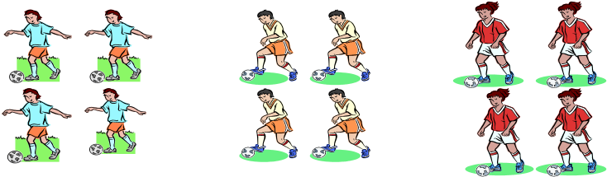

Early recordings will be pictorial representations that the children can divide by circling groups.
Example: There are 15 children working in groups of 3. How many groups are there going to be?

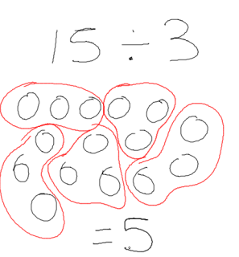

This differs from the previous physical representation as children are now grouping into 3s rather than sharing.
Children will eventually solve problems using a number line and repeated addition.
Example: 36 ÷ 4
Here the addition of 4 has been repeated 9 times leading to the answer of 9.

0

35
16
8
12
4

20
24
28
32
36

As children become more confident with repeated addition and multiplication tables they can progress onto jumping in multiples on the number line.
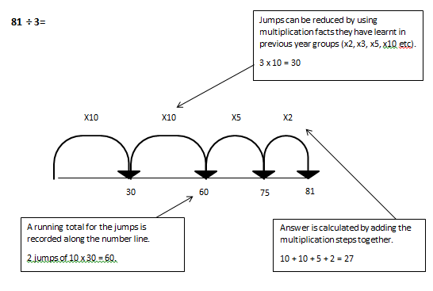
Example:
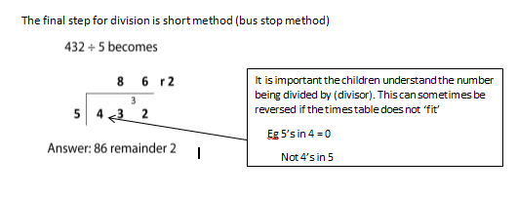
Key Stage 1

Fractions of an amount

Initially, shapes will be used to represent and find a unit fraction of an amount I.E. $\frac{1}{2}$ of a square. This will progress on to using concrete objects to find a unit fraction of an amount I.E. $\frac{1}{6}$ of 12 counters by sorting items equally into the correct number of groups and finding how many are in each group.
This will progress onto children representing the calculation by drawing.

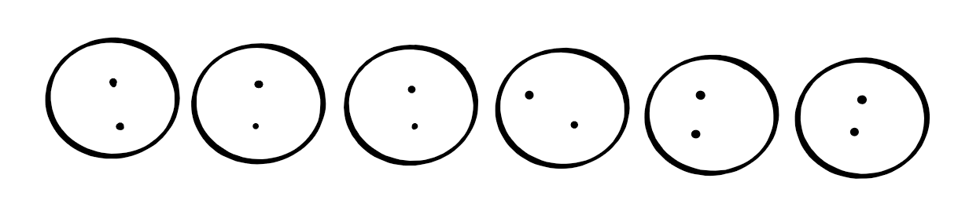
Example: $\frac{1}{6}$ of 12
Using the denominator to identify how many groups, the children would draw the number of groups and split the amount equally between them.
Children would then count how many are in one group.

As children become more confident, they can begin to find non-unit fractions of an amount I.E. $\frac{2}{5}$ of 25.
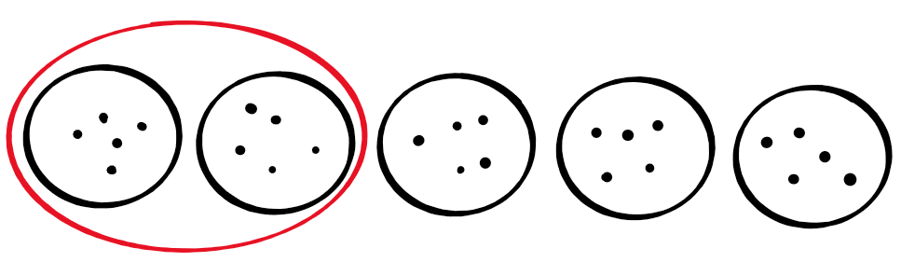
Example: $\frac{2}{5}$ of 25
Initially following the same steps as a unit fraction of an amount and then using the numerator to identify how many groups they need to count.

To extend pupils further, they can begin to use the inverse to solve missing number questions.

Key Stage 2

Key Stage 2

Addition

In Key Stage 2, children will move towards a standard formal written method of addition (column method). Calculations will be recorded with each digit in place value order vertically. Calculations beginning on the right, carrying forward any additions that create a 2 digit answer.
Digits are lined up in columns linked to their place value (HTU).
Addition of 9 + 2 equals 11. The first digit (one) is carried forwards underneath the equation to be added onto the addition of the next set of numbers.

Extension and Progression.

With a consolidated method in addition, children will be extended through number of digits, decimal number and numbers of varied length.

Examples:

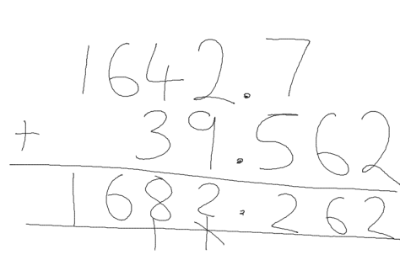
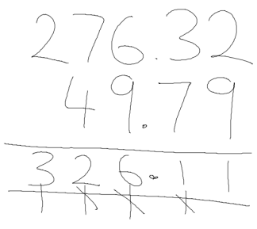
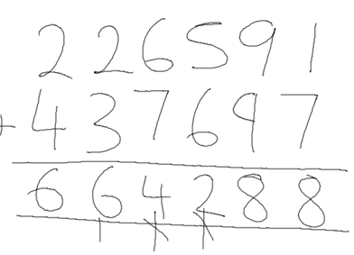

Key Stage 2

Subtraction

Entering into Key Stage 2, children will progress onto using decomposition for subtractions. Like column addition, operations are set out into in place value columns.

Subtractions starting on the right hand side.
2 minus 7

If subtractions are not possible without creating a negative number children can ‘borrow’ from the columns to the right.
2-7 =would create a negative number.
10 is borrowed from the column on the left creating 12 – 7 = 5
If a number is borrowed that column reduces by the value of 1
Digit 9 now becomes 8.

Extension and Progression
Once children have consolidated the formal written method of decomposition, they will be extended through number of digits and decimal numbers.

Examples:

1297.6 – 429.8 491.7-156.931
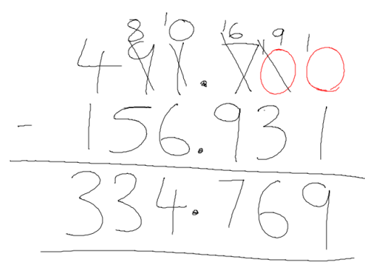
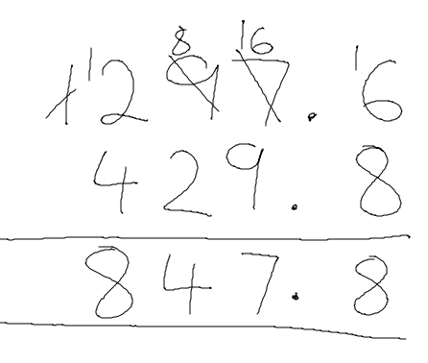

0’s added to the hths and thths as place holders to keep the numbers the same length and remind children of the equation
0 - 1

Key Stage 2
Multiplication

Throughout Key Stage 2, children will refine their understanding of multiplication through the formal written method of short of multiplication.

Children need to understand the carrying of forward of products that give a 2 digit answer.
6 x 4 = 24
The 2 carries forward to the next column and is added to the next answer

When multiplying by a number with a tens value children need to be aware of place value
20 x 4 not 2x4
0 is used as a place holder to ensure the columns are aligned

Extension and Progression.

To further challenge the children they can begin to look at more digits or decimals numbers. With decimal numbers the children are encouraged to ‘jump out’ the decimal multiply to two whole integers and then jump the decimal back in.
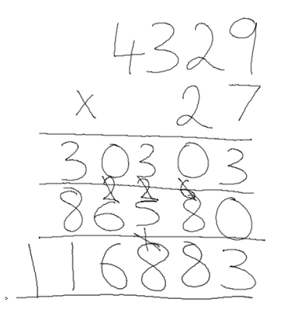
Examples: 4329 x 27

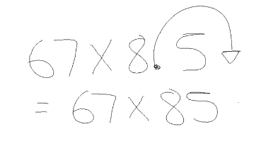
67 x 8.5 = 569.5

The decimal point is ‘jumped out to make the number more manageable.

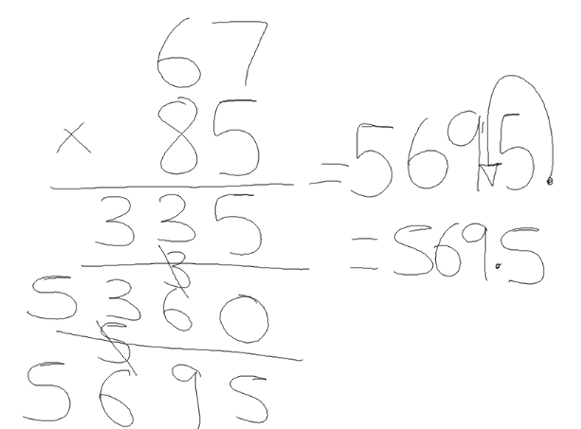
The decimal point is now jumped back in the same number of times it was jumped out to balance the equation.

Key Stage 2

Division

As the children enter Key Stage 2, they will consolidate their understanding of division using a number line and repeated addition with known multiplication tables.
Jumps can be reduced by using multiplication facts they have learnt in previous year groups (x2, x3, x5, x10 etc).
3 x 10 = 30
81 ÷ 3=

X2
X5
X10
X10

81
75
60
30
A running total for the jumps is recorded along the number line.
2 jumps of 10 x 30 = 60.

Answer is calculated by adding the multiplication steps together.
10 + 10 + 5 + 2 = 27

The final step for division is short method (bus stop method)
It is important the children understand the number being divided by (divisor). This can sometimes be reversed if the times table does not ‘fit’
Eg 5’s in 4 = 0
Not 4’s in 5

Extension and Progression

Once the children to have consolidated short division they can be extended by recording their remainders as decimal numbers and finally into long division for larger divisors.

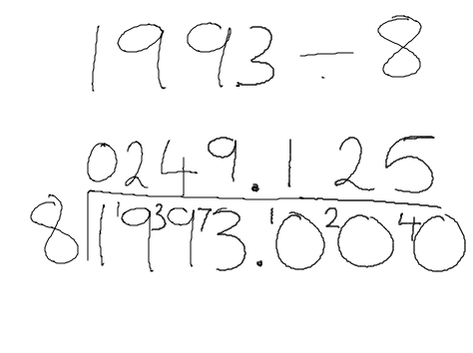
Examples:
Here the remainder of 1 has been divided into by 8 creating a decimal rather than representing the remainder as r1 or ⅛. 0 is used as a place holder to allow the remainder to be carried over.

Here the divisor (17) is too large to easily use the short division method. This method follows similar steps but the closest multiple is written underneath and then subtract from the dividend.

Next the children ask how many times 17 goes into 23. This time it goes in 1 time which is again put on the top row. The multiple (17) is placed underneath and the subtracted from the original 23 to give a remainder of 6.

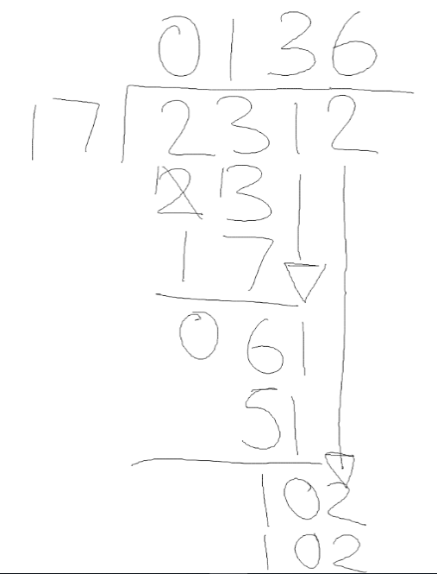
Children ask themselves how many times 17 would go into 2. The answer is 0 which is put at the top and we then drop the 3 down to make 23 for the next part.

The next digit in the dividend is now dropped down to create 61 and the children again ask themselves how many times 17 goes into 61. The process of finding the multiple, subtracting and dropping the next digit down continues until there are no digits left.

Key Stage 2

Fractions of an amount

In Key Stage 2, children will move towards a written method to find fractions of an amount by dividing the amount by the denominator and then multiplying by the numerator.
Children will initally be encouraged to make links between the groups drawn in Key Stage One and diving by the denominator and counting the number of groups with multiplying by the numerator.
Example:
Multiply by the numerator
Divide by the denominator
$$\frac{4}{5} of 455=204$$
$$455÷5=91$$
$$91×4=204$$

Children will be extended by using the inverse to solve missing number equations.
Example:
Multiply by the denominator
Divide by the numerator
$$\frac{4}{5} of ?=44$$
$$44÷4=11$$
$$11×5=55$$

Key Stage 2

Adding Fractions

Entering Key Stage two, children will build on their knowledge of fractions of shapes by beginning to use a formal method to add fractions. Initally, this would be supported with visual representations.
Example:
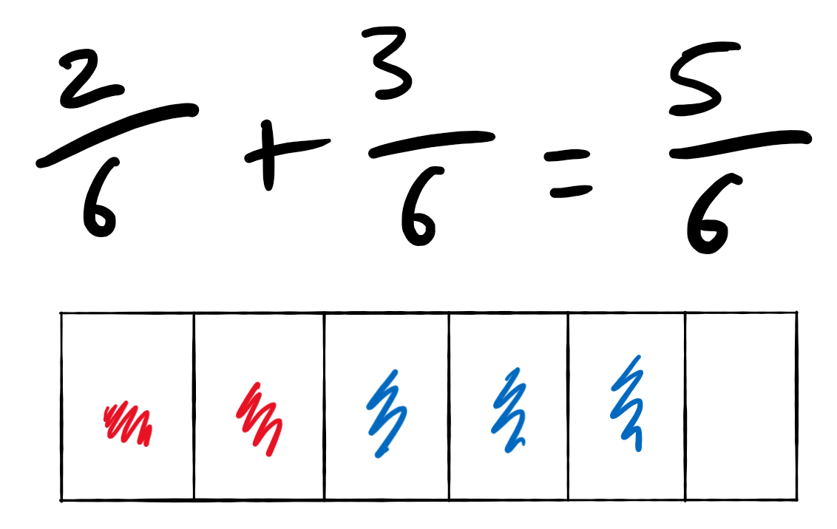
Numerator + Numerator
Denominator stays the same

Once children have consolidated this method, they will be extended in a number of ways:
- Adding fractions with different denominators, for example:
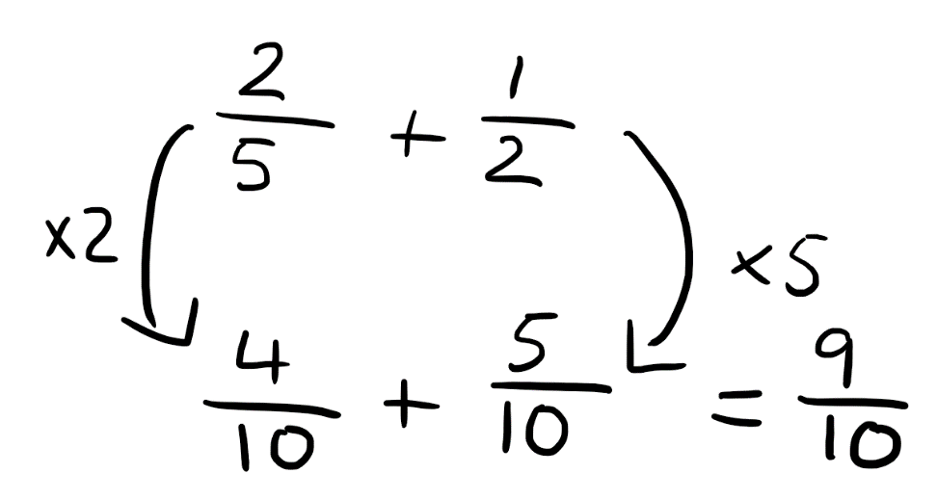
Children need to find a common denominator before adding by either finding the lowest common multiple or multiplying by the denominator of the other fraction.
Both the numerator and denominator need to be multiplied by the same number.

- Adding to give an answer larger than 1, for example:

Children could use knowledge of improper fractions to convert this into a mixed number.
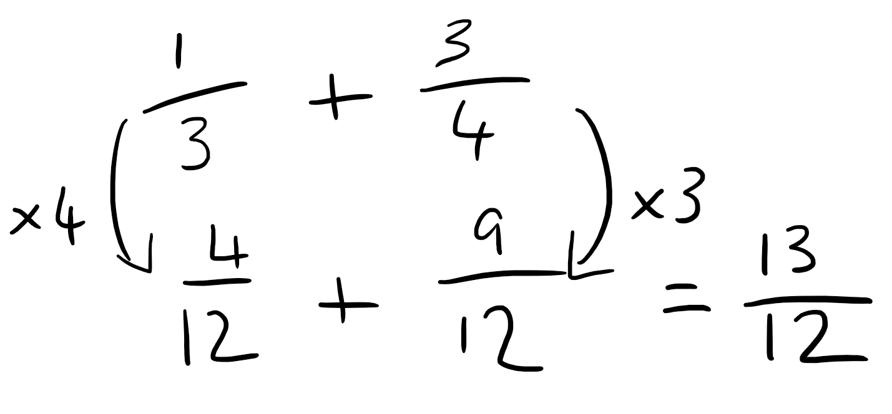

Children should convert mixed numbers into improper fractions before adding by multiplying the whole number by the denominator and adding the numerator.

In this case: 3 x 1 + 1 = 4 which gives $\frac{4}{3}$ as the improper fraction.

- Adding mixed numbers, for example:

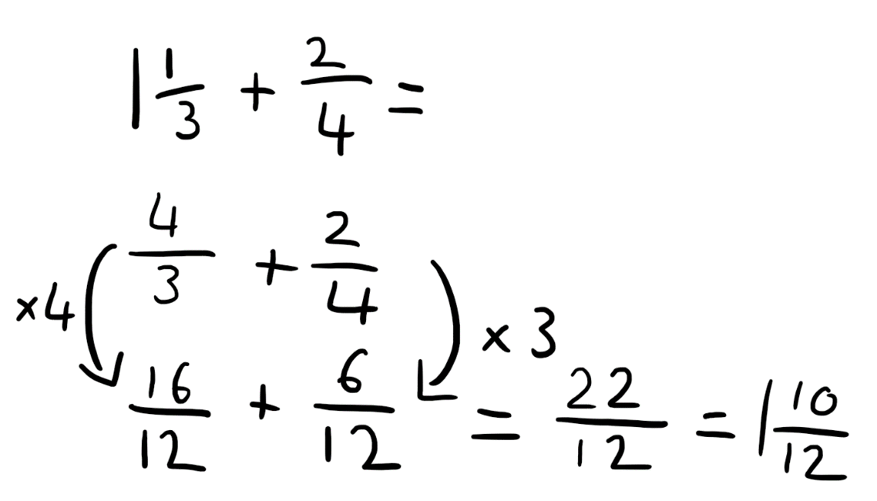

- Simplifying answers, for example:
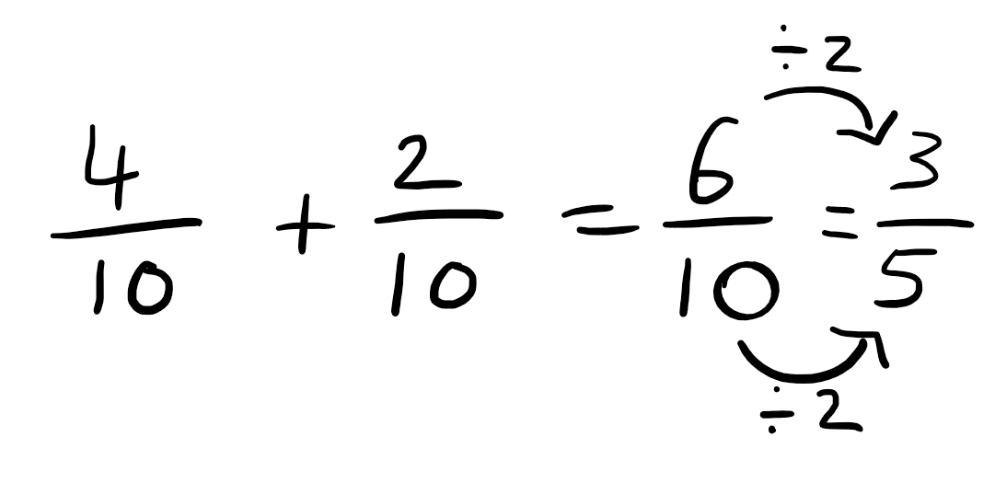
Numerator and denominator should be divided by the same number to the smallest possible fraction.
Key Stage 2

Subtracting Fractions

Entering Key Stage two, children will build on their knowledge of fractions of shapes by beginning to use a formal method to subtract fractions. Initally, this would be supported with visual representations.
Example:
Numerator - Numerator
Denominator stays the same
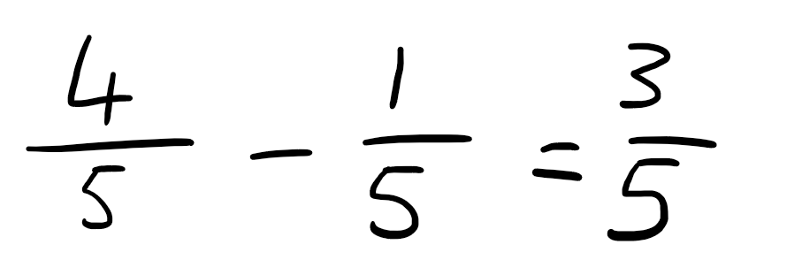

Once children have consolidated this method, they will be extended in a number of ways:
- Subtracting fractions with different denominators, for example:

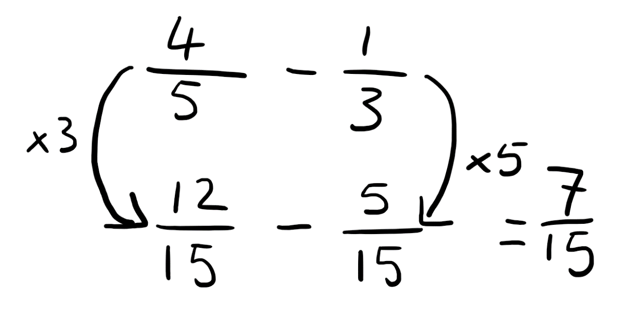

Children need to find a common denominator before subtracting by either finding the lowest common multiple or multiplying by the denominator of the other fraction.
Both the numerator and denominator need to be multiplied by the same number.

Children should convert mixed numbers into improper fractions before subtracting by multiplying the whole number by the denominator and adding the numerator.

In this case: 6 x 1 + 2 = 8 which gives $\frac{8}{6}$ as the improper fraction.
- Subtracting mixed numbers, for example:

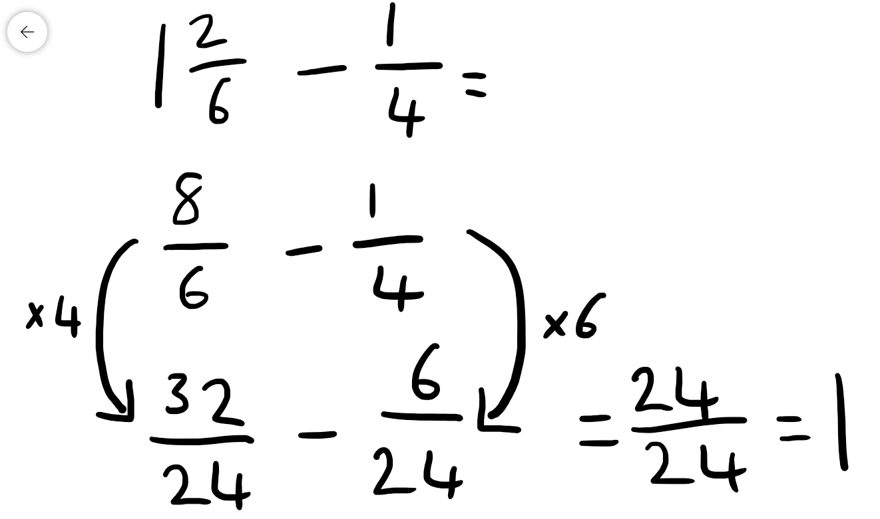

Children need to recognise and convert whole numbers.

- Or by simplifying answers as with addition.

Key Stage 2

Multiplying Fractions

In Key Stage 2, children will be introduced to multiplying fractions using a formal method (numerator multiplied by numerator and denominator multiplied by denominator).
Example:
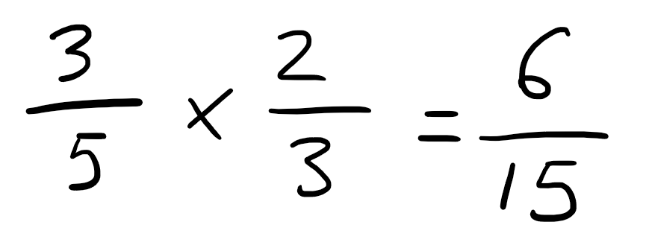
Once children have consolidated this method, they will be extended in a number of ways:
- Multiplying integers, for example:
Integers must be converted to fractions before multiplying.
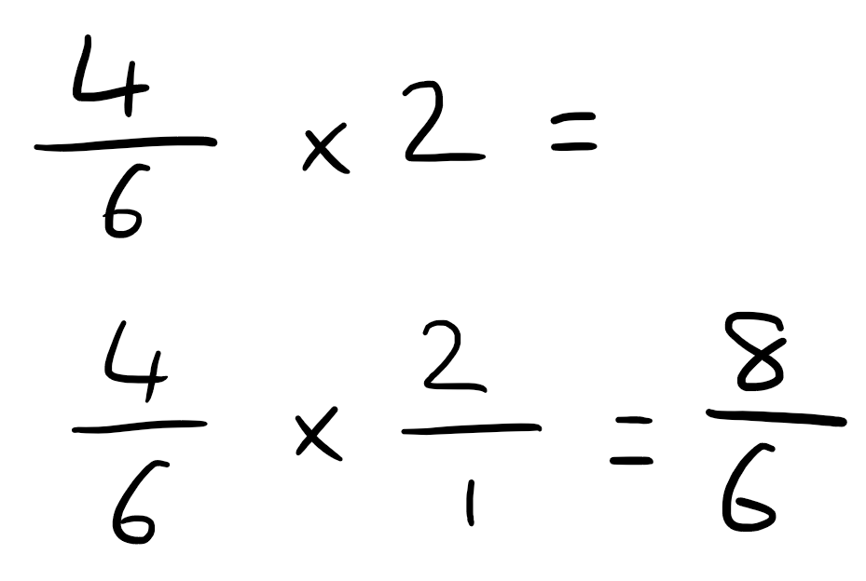
Children could use knowledge of improper fractions to convert this into a mixed number.

Children should convert mixed numbers into improper fractions before multiplying by multiplying the whole number by the denominator and adding the numerator.

In this case: 2 x 4 + 3 = 11 which gives $\frac{11}{4}$ as the improper fraction.

- Multiplying mixed numbers, for example:
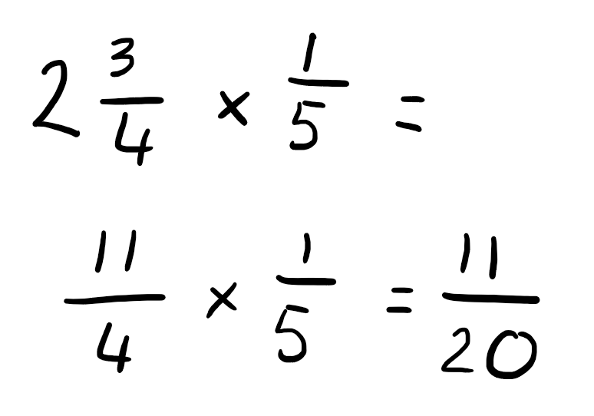

- Or by simplifying answers as with addition.

Key Stage 2

Dividing Fractions

In Key Stage 2, children will be introduced to dividing fractions using a formal method – keep it, flip it, change it (KFC).
2) Flip the second fraction upside down.
Example:
1) Keep the first fraction the same.
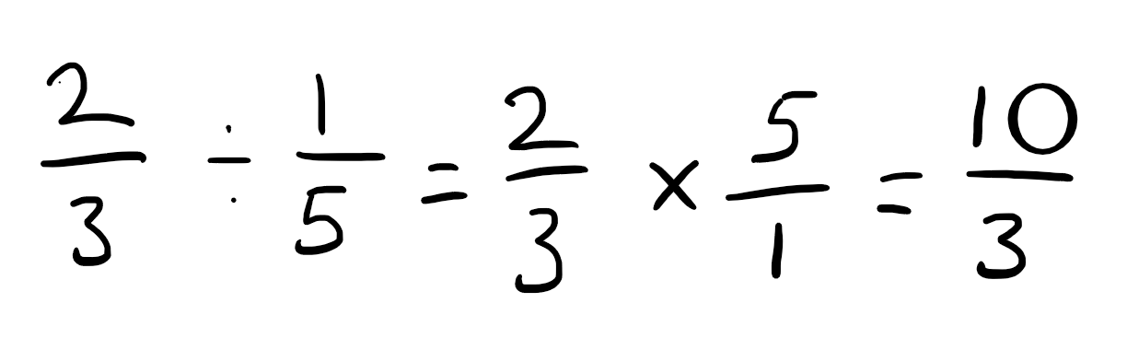
3) Change the divide to a times.

Children could use knowledge of improper fractions to convert this into a mixed number.

Once children have consolidated this method, they will be extended in a number of ways:
- Dividing mixed numbers, for example:
Children should convert mixed numbers into improper fractions before dividing by multiplying the whole number by the denominator and adding the numerator.
In this case: 3 x 4 + 1 = 13 which gives $\frac{13}{4}$ as the improper fraction.
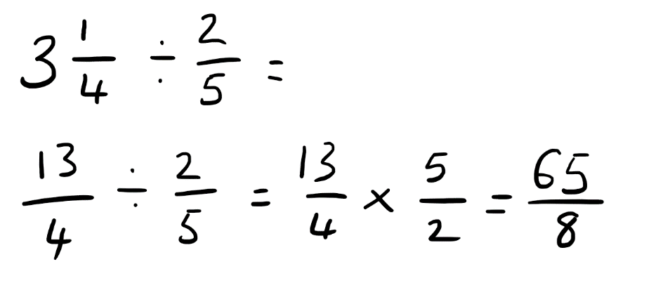
- Dividing integers, for example:
Integers must be converted to fractions before dividing.

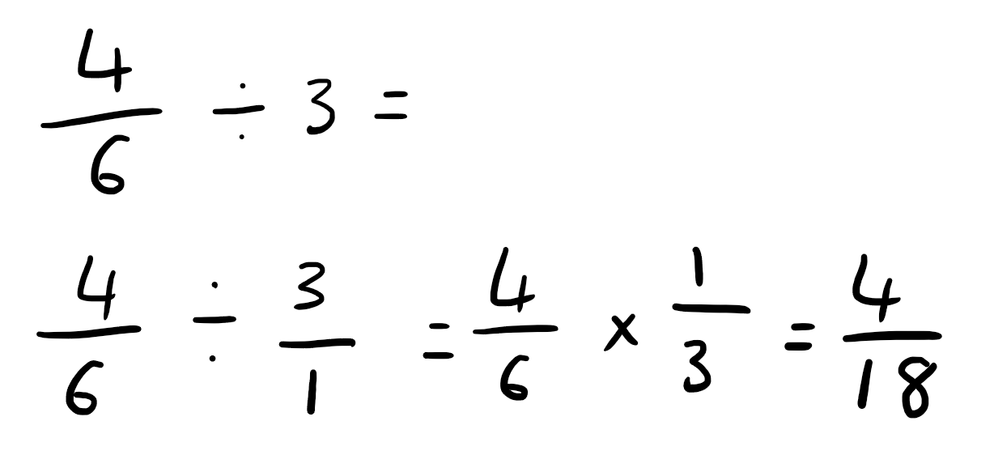
- Or by simplifying answers as with addition.

