Your Designated Child Protection Team are:
Mrs Georgie Robinson
Assistant Principal
Senior Designated Safeguarding Lead

Mrs Leanna Govan  Family Support Worker  Deputy Designated Safeguarding Lead | 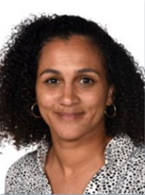
Mrs Stephanie Boyers
Assistant Principal
Deputy Designated Safeguarding Lead
Mr Michael Hayes
Phase 3 Lead
Deputy Designated Safeguarding Lead

